Chapter 3, Problem 91.

For the transistor circuit of Fig. 3.127, find I_{B}, V_{CE}, and v_{o}. Take β = 200, V_{BE} = 0.7V.

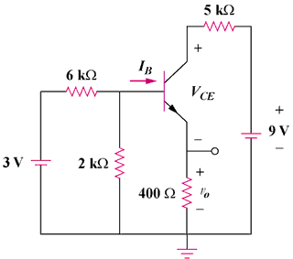

Figure 3.127
For Prob. 3.91.

